**Selection of a café location**

Toporkova Evgeniia

February 25, 2019

# Introduction

## Background

Nowadays there is a vast amount of catering places. Some of them are owned by individuals others by companies. Success of any type of catering, either it’s a sole proprietorship or a part of chain, is depended on the it’s location. Choosing the right place for locating may become crucial for opening a café since it defines visibility and accessibility for potential customers. The importance of a proper location is widely recognized by the business.

## Problem

Data that might contribute to determining café location might include information about attractions in the area, nearby venues, transport accessibility, potential competitors. This project aims to determine a proper area to place a small café in Kiev, Ukraine.

## Interest

Companies and sole proprietorships would be interested in accurate choosing of a café location for business values.

# Data

Based on definition of our problem, factors that will influence my decision are:

1. number of existing cafes in the neighborhood (any type of cafe);
2. number of and distance to cafes in the neighborhood, if any;
3. distance of neighborhood from city center.

I decided to use regularly spaced grid of locations, centered around city center, to define our neighborhoods.

Following data sources will be needed to extract/generate the required information:

1. centers of candidate areas will be generated algorithmically and approximate addresses of centers of those areas will be obtained using Foursquare API;
2. number of cafes and their type and location in every neighborhood will be obtained using Foursquare API;
3. coordinate of Kiev center will be obtained using geocoder Nominatum of well known Kiev location (Khreshchatyk Street) (Table 1).

Table 1. Part of the table with collected information about candidate neighborhood centers.

|  |  |  |  |  |  |
| --- | --- | --- | --- | --- | --- |
| **Address** | **Distance from center** | **Latitude** | **Longitude** | **X** | **Y** |
| 3, Васильківська вулиця, Голосіїв, Голосіївськ... | 5992.495307 | 50.395913 | 30.506130 | 322754.092023 | 5.585625e+06 |
| 4а, Владислава Заремби провулок, Добрий Шлях, ... | 5840.376700 | 50.396094 | 30.514563 | 323354.092023 | 5.585625e+06 |
| 2а, Листопадна вулиця, Добрий Шлях, Голосіївсь... | 5747.173218 | 50.396274 | 30.522997 | 323954.092023 | 5.585625e+06 |
| Продукти, 29, Науки проспект, Добрий Шлях, Гол... | 5715.767665 | 50.396453 | 30.531431 | 324554.092023 | 5.585625e+06 |
| 42, Столєтова вулиця, Багринова гора, Голосіїв... | 5747.173218 | 50.396632 | 30.539865 | 325154.092023 | 5.585625e+06 |

All the collected cafes in our area of interest and coffee places are showed on the map in different color (Figure 1). We know which ones are coffee places, we also know which cafes exactly are in vicinity of every neighborhood candidate center.

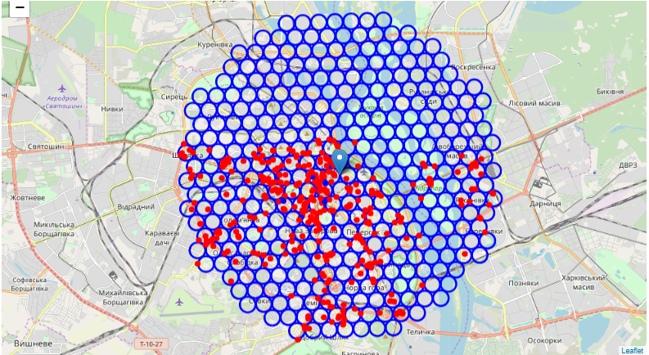

Figure 1. Collected cafes and coffee places on the map of Kiev.

This concludes the data gathering phase - we're now ready to use this data for analysis to produce the report on optimal locations for a new coffee place.

# Methodology

In this project we will direct our efforts on detecting areas of Kiev that have low cafe density, particularly those with low number of coffee places. We will limit our analysis to area ~6km around city center.

In first step we have collected the required data: location and type (category) of every cafe within 6km from Kiev center (Khreschatyk). We have also identified coffee places (according to Foursquare categorization).

Second step in our analysis will be calculation and exploration of 'cafe density' across different areas of Kiev - we will use heatmaps to identify a few promising areas close to center with low number of cafes in general (and no coffee places in vicinity) and focus our attention on those areas.

In third and final step we will focus on most promising areas and within those create clusters of locations that meet some basic requirements established in discussion with stakeholders: we will take into consideration locations with no more than two cafes in radius of 250 meters, and we want locations without coffee places in radius of 400 meters. We will present map of all such locations but also create clusters (using k-means clustering) of those locations to identify general zones / neighborhoods / addresses which should be a starting point for final 'street level' exploration and search for optimal venue location by stakeholders.

# Analysis

## Basic analysis

After some basic explanatory data analysis and some additional info from our raw data I got the following information: average number of cafes in every area with radius=300m: 0.862637362637, average distance to closest coffee place from each area center: 390.08381856608696.

OK, so on average coffee place can be found within ~ 390m from every area center candidate. That's fairly close, so we need to filter our areas carefully.

I created a map showing heatmap / density of Coffee places to extract some meaningful info from that. Borders of Kiev boroughs on our map and a few circles indicating distance of 1km, 2km and 3km from Khreschatyk are shown on the map (Figure 2).

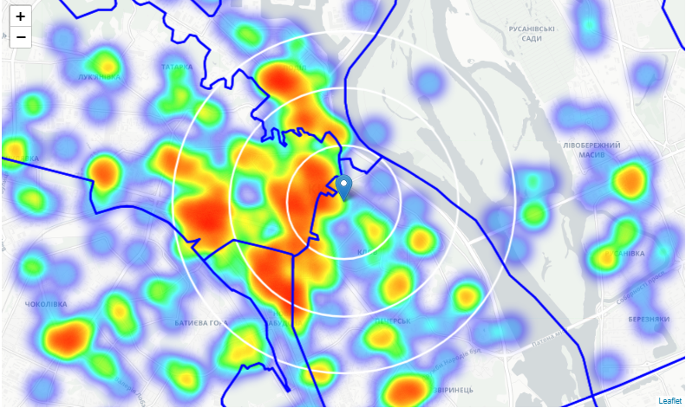

Figure 2. Heatmap of Coffee places in Kiev center.

Based on this we will now focus our analysis on areas south-west, south, south-east and east from KIev center - we will move the center of our area of interest and reduce it's size to have a radius of 2.5km. This places our location candidates mostly in borough Pechersk (another potentially interesting borough is Podilsky with large low cafe density north-west from city center, however this borough is less interesting to stakeholders as it's mostly residental and less popular with tourists).

## Information about Pechersk

Analysis of popular travel guides and web sites often mention Pechersk as beautifull, historical, rich with culture, prestigious Kiev neighborhood popular with tourists and loved by Kiev citizens.

"Pecherskyi District (Ukrainian: Печерський район) is an urban district of Kiev, the capital of Ukraine. It line within the eponymous historical neighborhood, while also including some other historical areas. The Pechersk (Ukrainian: Печерськ, Pechers'k) neighborhood is located on the hills adjoining the right bank of the Dnieper River. The two geographic entities are often confused together. The Pecherskyi District can be considered as the very heart of Ukraine."

"Many other historical and architectural monuments are situated here. Here is located Askold's Grave which was depicted by Taras Shevchenko on his painting of 1846. Around the burial was created the Askold Grave Park and was built a wooden church that later was reconstructed into the brick one designed by Andriy Ivanovych Melensky. The church's name is the Saint Nicolas the Miracle-worker Church or Rotonda. There are large residential, industrial, healthcare and military areas in the district, as well as a few picturesque parks and sports venues like the Lobanovsky Dynamo Stadium. Many administrative and educational facilities are situated in the district. The famous Art nouveau House with Chimaeras and gigantic statue of Mother Motherland are also located in the Pecherskyi District (Lypky and Zvirynets respectively).

After the declaration of Ukrainian independence in 1991, the Pecherskyi District retained and developed its role also becoming a luxury residential area. The few large industrial companies located in the district are considering to move elsewhere, pocketing a significant profit from the real estate they hold from the times of the Soviet Ukraine."(wikipedia.org)

"Ancient city of Kiev with its numerous interesting sights, varied historic monuments, makes for a fantastic holiday destination" (kievkyivukraine.com)

Popular with tourists, relatively close to city center and well connected, that borough appear to justify further analysis.

## Analysis of Pechersk borough

Let's define new, more narrow region of interest, which will include low-cafe-count parts of Pecherskyi District closest to Khreshchatyk. I created a more dense grid of location candidates restricted to our new region of interest (location candidates 100m appart). Two most important things for each location candidate: number of cafes in vicinity (we'll use radius of 250 meters) and distance to closest Coffee place (Table 2).

Table 2. Part of the table with information about cafes in vicinity in Pechersk.

| **Cafes nearby** | **Distance to Coffee place** | **Latitude** | **Longitude** | **X** | **Y** |  |
| --- | --- | --- | --- | --- | --- | --- |
| 1 | 160.657207 | 50.412004 | 30.536957 | 325004.092023 | 5.587340e+06 |  |
| 0 | 260.039489 | 50.412033 | 30.538363 | 325104.092023 | 5.587340e+06 |  |
| 0 | 396.143180 | 50.412618 | 30.529183 | 324454.092023 | 5.587427e+06 |  |
| 0 | 297.891284 | 50.412647 | 30.530589 | 324554.092023 | 5.587427e+06 |  |
| 1 | 201.367860 | 50.412677 | 30.531995 | 324654.092023 | 5.587427e+06 |  |
| 1 | 111.170197 | 50.412707 | 30.533401 | 324754.092023 | 5.587427e+06 |  |
| 1 | 64.564778 | 50.412737 | 30.534807 | 324854.092023 | 5.587427e+06 |  |
| 1 | 126.405729 | 50.412767 | 30.536214 | 324954.092023 | 5.587427e+06 |  |

We're interested only in locations with no more than two cafes in radius of 250 meters, and no Coffee places in radius of 400 meters. We now have a bunch of locations fairly close to Khreschatyk(mostly in Pechersk and west corner of Dnipropetrovsk district), and we know that each of those locations has no more than two cafes in radius of 250m, and no Coffee place closer than 400m. Any of those locations is a potential candidate for a new Coffee place, at least based on nearby competition. Looking good. What we have now is a clear indication of zones with low number of cafes in vicinity, and no Coffee places at all nearby.

Those locations are clustered to create centers of zones containing good locations. Those zones, their centers and addresses will be the final result of our analysis. The clusters represent groupings of most of the candidate locations and cluster centers are placed nicely in the middle of the zones 'rich' with location candidates.

Addresses of those cluster centers will be a good starting point for exploring the neighborhoods to find the best possible location based on neighborhood specifics (Figure 3, Figure 4).

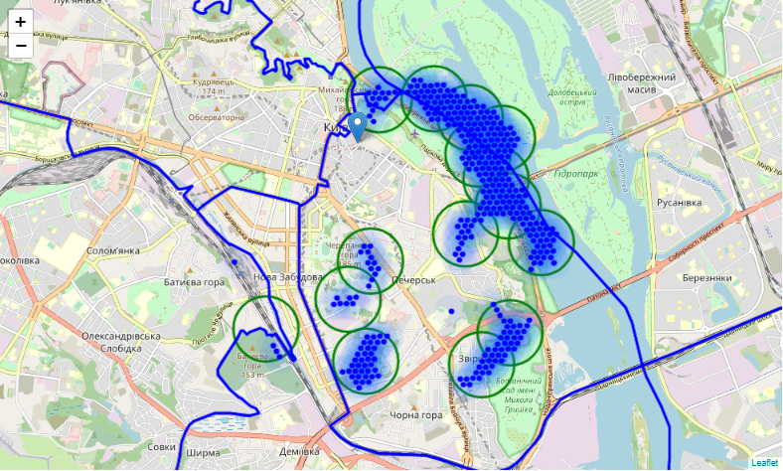

Figure 3. Zones on a city map using shaded areas to indicate the clusters.

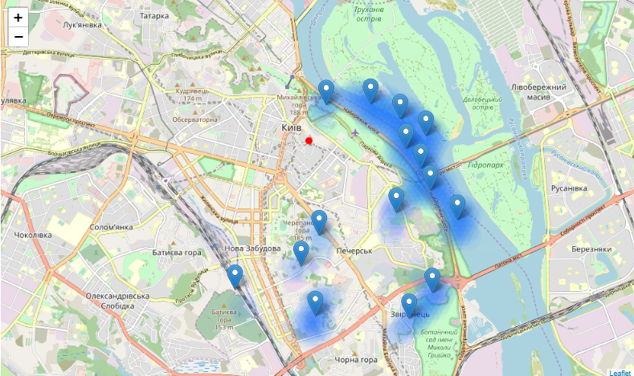

Figure 4. Centers of the zones on a city map.

Finally, those candidate area centers are reversed geocode to get the addresses which can be presented to stakeholders. Since Kiev is crossed with Dnieper river, only 8 of those areas will be presented because 7 of them are located in the river or across it. So final results in terms of addresses are:

1. 1/22, Академіка Філатова вулиця, Черепанова гора, Чорна гора, Печерський район, Київ, 01042 => 3.3km from Khreshchatyk
2. 11, Бастіонна вулиця, Бусова гора, Звіринець, Печерський район, Київ, 01014 => 3.9km from Khreshchatyk
3. 12, Лабораторний провулок, Черепанова гора, Печерськ, Печерський район, Київ, 01901 => 2.4km from Khreshchatyk
4. 50, Мічуріна вулиця, Царське Село, Звіринець, Печерський район, Київ, 01014 => 3.7km from Khreshchatyk
5. Вид на Поділ, Петрівська алея, Печерськ, Печерський район, Київ, 01008 => 0.7km from Khreshchatyk
6. 4, Миколи Грінченка вулиця, Деміївка, Голосіївський район, Київ, 03028 => 3.2km from Khreshchatyk
7. Київська фортеця, Лабораторний провулок, Черепанова гора, Печерськ, Печерський район, Київ, 01901 => 1.8km from Khreshchatyk
8. Києво-Печерська цитадель, Соборна площа, Царське Село, Печерськ, Печерський район, Київ, 01015 => 2.2km from Khreshchatyk

This concludes our analysis. We have created 8 addresses representing centers of zones containing locations with low number of cafes and no Coffee places nearby, all zones being fairly close to city center (all less than 4km from Khreshchatyk, and about half of those less than 2km from Khreshchatyk). Although zones are shown on map with a radius of ~500 meters (green circles), their shape is actually very irregular and their centers/addresses should be considered only as a starting point for exploring area neighborhoods in search for potential cafe locations. The zones are located in Pechersk boroughs, which we have identified as interesting due to being popular with tourists, fairly close to city center and well connected by public transport.

# Results and Discussion

Our analysis shows that although there is a great number of cafes in Kiev (~2000 in our initial area of interest which was 12x12km around Khreshchatyk), there are pockets of low cafe density fairly close to city center. Highest concentration of cafe was detected south and east from Khreshchatyk so we focused our attention to south, south-east and east from KIev center, corresponding to the borough Pechersk. Our attention was focused on Pechersk which offer a combination of popularity among tourists, closeness to city center, strong socio-economic dynamics and a number of pockets of low cafe density.

After directing our attention to this more narrow area of interest (covering approx. 5x5km south-east from Khreshchatyk) we first created a dense grid of location candidates (spaced 100m appart); those locations were then filtered so that those with more than two cafes in radius of 250m and those with an Coffee place closer than 400m were removed.

Those location candidates were then clustered to create zones of interest which contain greatest number of location candidates. Addresses of centers of those zones were also generated using reverse geocoding to be used as markers/starting points for more detailed local analysis based on other factors.

Result of all this is 8 (we created 15 but 7 of them are located in or across the Dnieper so we can't consider them) zones containing largest number of potential new cafe locations based on number of and distance to existing venues - both cafes in general and Coffee places particularly. This, of course, does not imply that those zones are actually optimal locations for a new cafe! Purpose of this analysis was to only provide info on areas close to Kiev center but not crowded with existing cafes (particularly Coffee places) - it is entirely possible that there is a very good reason for small number of cafes in any of those areas, reasons which would make them unsuitable for a new cafe regardless of lack of competition in the area. Recommended zones should therefore be considered only as a starting point for more detailed analysis which could eventually result in location which has not only no nearby competition but also other factors taken into account and all other relevant conditions met.

# Conclusion

Purpose of this project was to identify Kiev areas close to center with low number of cafes (particularly Coffee places) in order to aid stakeholders in narrowing down the search for optimal location for a new Cafe. By calculating cafe density distribution from Foursquare data we have first identified general borough that justify further analysis (Pechersk), and then generated extensive collection of locations which satisfy some basic requirements regarding existing nearby cafes. Clustering of those locations was then performed in order to create major zones of interest (containing greatest number of potential locations) and addresses of those zone centers were created to be used as starting points for final exploration by stakeholders.

Final decision on optimal cafe location will be made by stakeholders based on specific characteristics of neighborhoods and locations in every recommended zone, taking into consideration additional factors like attractiveness of each location (proximity to park or water), levels of noise / proximity to major roads, real estate availability, prices, social and economic dynamics of every neighborhood etc.